# DAD 220 Database Documentation Template

Complete these steps as you work through the directions for Project One. Replace the bracketed text with your screenshots and brief explanations of the work they capture. Each screenshot and its explanation should be sized to approximately one quarter of the page, with the description written below the screenshot. Follow these rules for each of the prompts and questions below. Review the example document located in the Project One Supporting Materials for assistance.

## Step One: Create a Database

1. Navigate to your online integrated development environment (IDE). List and record the SQL commands that you used to complete this step here:

Command: mysql

1. Create a database schema called QuantigrationUpdates. List out the database name. Provide the SQL commands you ran against MySQL to successfully complete this in your answer:

Command: create database QuantigrationUpdates;

show databases;

1. Using the entity relationship diagram (ERD) as a reference, create the following tables with the appropriate attributes and keys:
   1. A table named **Customers** in the QuantigrationUpdates database, as defined on the project ERD. Provide the SQL commands you ran against MySQL to complete this successfully in your answer:



Commands: use QuantigrationUpdates;

create table Customers(CustomerID INT, FirstName VARCHAR(25), LastName VARCHAR(25), Street VARCHAR(50), City VARCHAR(50), State VARCHAR(25), ZipCode INT, Telephone VARCHAR(15));

describe Customers;

Commands: ALTER TABLE Customers ADD PRIMARY KEY(CustomerID);

describe Customers;

* 1. A table named **Orders** in the QuantigrationUpdates database, as defined on the project ERD. Provide the SQL commands you ran against MySQL to complete this successfully in your answer:

Commands: create table Orders(OrderID INT, CustomerID INT, SKU VARCHAR(20), Description VARCHAR(50), PRIMARY KEY(OrderID), FOREIGN KEY(CustomerID) REFERENCES Customers(CustomerID));

describe Orders;

* 1. A table named **RMA** in the QuantigrationUpdates database, as defined on the project ERD. Provide the SQL commands you ran against MySQL to complete this successfully in your answer:

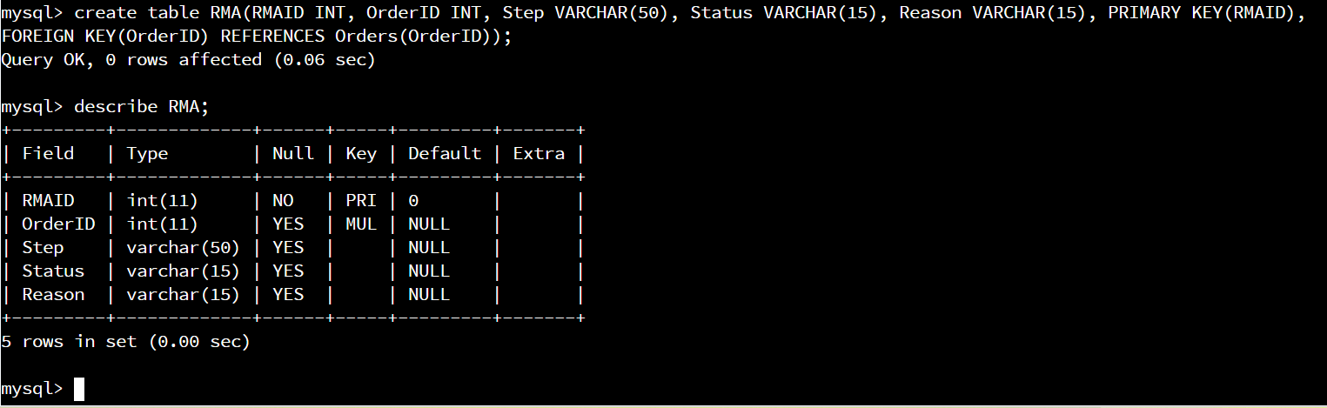

Commands: create table RMA(RMAID INT, OrderID INT, Step VARCHAR(50), Status VARCHAR(15), Reason VARCHAR(15), PRIMARY KEY(RMAID), FOREIGN KEY(OrderID) REFERENCES Orders(OrderID));

describe RMA;

1. **Update your existing tables** from “Customer” to “Collaborator” using SQL based on this change in requirements. Provide the SQL commands you ran against MySQL to complete this successfully in your answer:
   1. Rename all instances of “Customer” to “Collaborator.”

Commands: alter table Orders drop foreign key Orders_ibfk_1;

alter table Orders change CustomerID CollaboratorID int;

describe Orders;

Commands: alter table Customers change CustomerID CollaboratorID int;

describe Orders;

Commands: rename table Customers to Collaborators;

show tables;

## Step Two: Load and Query the Data

1. **Import the data from each file into tables.** 
   * Use the QuantigrationUpdates database, the three tables you created, and the three CSV files preloaded into Codio.
   * Use the import utility of your database program to load the data from each file into the table of the same name. You will perform this step three times, once for each table.

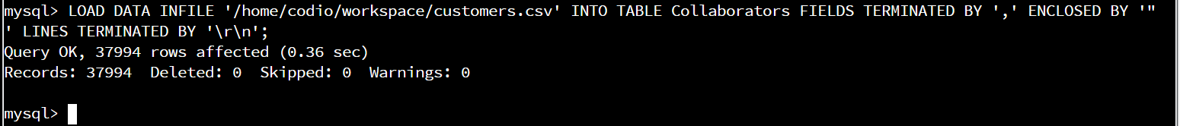Commands: LOAD DATA INFILE '/home/codio/workspace/customers.csv' INTO TABLE Collaborators FIELDS TERMINATED BY ',' ENCLOSED BY '"' LINES TERMINATED BY '\r\n';

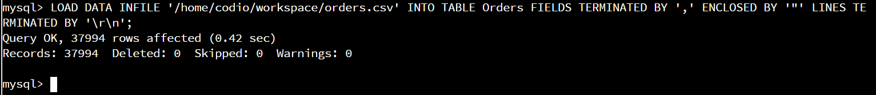Commands: LOAD DATA INFILE '/home/codio/workspace/orders.csv' INTO TABLE Orders FIELDS TERMINATED BY ',' ENCLOSED BY '"' LINES TERMINATED BY '\r\n';

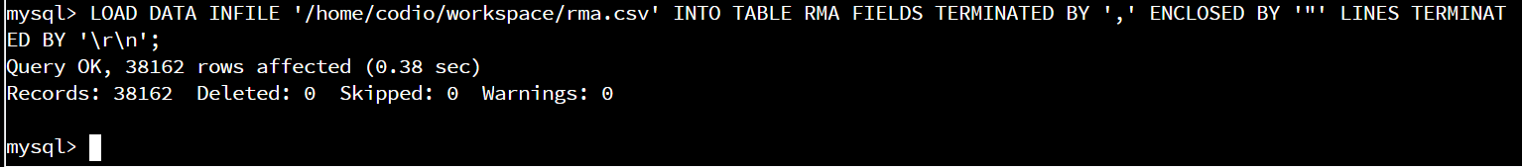Commands: LOAD DATA INFILE '/home/codio/workspace/rma.csv' INTO TABLE RMA FIELDS TERMINATED BY ',' ENCLOSED BY '"' LINES TERMINATED BY '\r\n';

1. **Write basic queries against imported tables to organize and analyze targeted data.** For each query, replace the bracketed text with a screenshot of the query and its output. You should also include a 1- to 3-sentence description of the output.
   * Write an SQL query that returns the **count** of orders for customers located only in the city of Framingham, Massachusetts.
     1. How many records were returned?

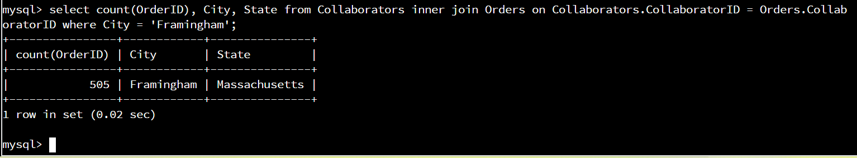Commands: select count(OrderID), City, State from Collaborators inner join Orders on Collaborators.CollaboratorID = Orders.CollaboratorID where City = 'Framingham';

There were 505 records returned for orders in Framingham, Massachusetts.

* + Write an SQL query to **select all** of the Customers located in the state of Massachusetts.
    1. Use a WHERE clause to limit the number of records in the Customers table to only those who are located in Massachusetts.
    2. Record an answer to the following question: How many records were returned?

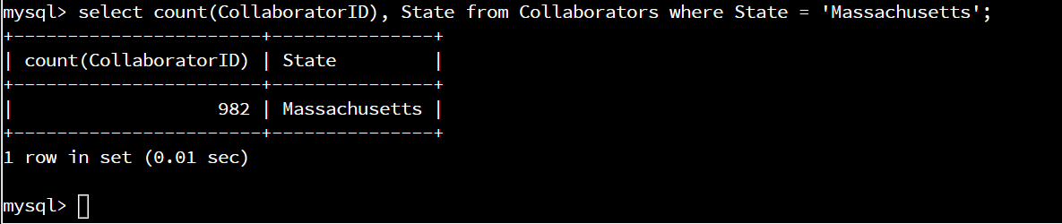

Commmand: select count(CollaboratorID), State from Collaborators where State = ‘Massachusetts';

There were 982 records returned for customers(collaborators) in Massachusetts.

* + Write a SQL query to insert four new records into the Orders and Customers tables using the following data:
    1. Customers Table

| **CustomerID** | **FirstName** | **LastName** | **StreetAddress** | **City** | **State** | **ZipCode** | **Telephone** |
| --- | --- | --- | --- | --- | --- | --- | --- |
| 100004 | Luke | Skywalker | 15 Maiden Lane | New York | NY | 10222 | 212-555-1234 |
| 100005 | Winston | Smith | 123 Sycamore Street | Greensboro | NC | 27401 | 919-555-6623 |
| 100006 | MaryAnne | Jenkins | 1 Coconut Way | Jupiter | FL | 33458 | 321-555-8907 |
| 100007 | Janet | Williams | 55 Redondo Beach Blvd | Torrence | CA | 90501 | 310-555-5678 |









Commands: insert into Collaborators values (100004, 'Luke', 'Skywalker', '15 Maiden Lane', 'New York', 'NY', 10222, '212-555-1234');

insert into Collaborators values (100005, 'Winston', 'Smith', '123 Sycamore Street', 'Greensboro', 'NC', 27401, '919-555-6623');

insert into Collaborators values (100006, 'MaryAnne', 'Jenkins', '1 Coconut Way', 'Jupiter', 'FL', 33458, '312-555-8907');

insert into Collaborators values (100007, 'Janet', 'Williams', '55 Redondo Beach Blvd', 'Torrence', 'CA', 90501, '310-555-5678');

* + 1. Orders Table

| **OrderID** | **CustomerID** | **SKU** | **Description** |
| --- | --- | --- | --- |
| 1204305 | 100004 | ADV-24-10C | Advanced Switch 10GigE Copper 24 port |
| 1204306 | 100005 | ADV-48-10F | Advanced Switch 10 GigE Copper/Fiber 44 port copper 4 port fiber |
| 1204307 | 100006 | ENT-24-10F | Enterprise Switch 10GigE SFP+ 24 Port |
| 1204308 | 100007 | ENT-48-10F | Enterprise Switch 10GigE SFP+ 48 port |









Command: insert into Orders values (1204305, 100004, 'ADV-24-10C', 'Advanced Switch 10GigE Copper 24 port');

insert into Orders values (1204306, 100005, 'ADV-48-10F', 'Advanced Switch 10 GigE Copper/Fiber 44 port copper 4 port fiber');

insert into Orders values (1204307, 100006, 'ENT-24-10F', 'Enterprise Switch 10GigE SFP+ 24 Port');

insert into Orders values (1204308, 100007, 'ENT-48-10F', 'Enterprise Switch 10GigE SFP+ 48 port');

* + In the Customers table, perform a query to count all records where the city is Woonsocket, Rhode Island.
    1. How many records are in the Customers table where the field “city” equals “Woonsocket”?

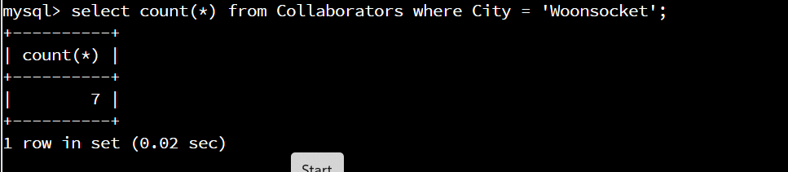

Command: select count(*) from Collaborators where City = 'Woonsocket';

The query returned 7 records for the Collaborator table with the city = Woonsocket.

* + In the RMA database, update a customer’s records.
    1. Write an SQL statement to select the current fields of **status** and **step** for the record in the **RMA** table with an **orderid** value of “5175.”
       1. What are the current status and step?

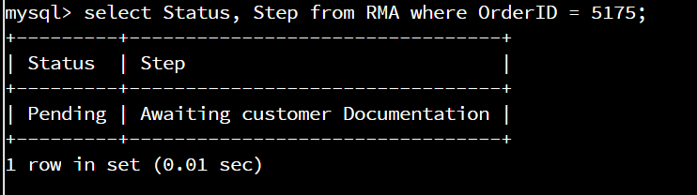select Status, Step from RMA where OrderID = 5175;

The current status is ‘Pending’ and the current step is ‘Awaiting customer Documentation’.

* + 1. Write an SQL statement to update the **status** and **step** for the **OrderID**, 5175 to **status** = “Complete” and **step** = “Credit Customer Account.”
       1. What are the updated **status** and **step** values for this record?

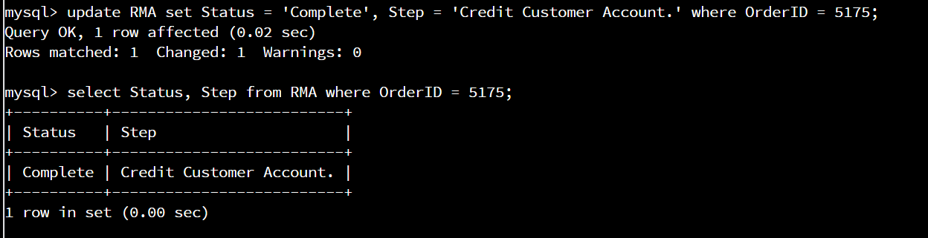 Command: update RMA set Status = 'Complete', Step = 'Credit Customer Account.' where OrderID = 5175;

select Status, Step from RMA where OrderID = 5175;

The updated status is ‘Complete’ and the updated step is ‘Credit Customer Account.’

* + Delete RMA records.
    1. Write an SQL statement to delete all records with a reason of “Rejected.”
       1. How many records were deleted?

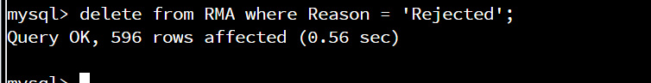Command: delete from RMA where Reason = 'Rejected';

There were 596 records deleted with the Reason = ‘Rejected’.

1. **Create an output file of the required query results.** Write an SQL statement to list the contents of the **Orders** table and send the output to a file that has a .csv extension.



Command: select * from Orders into outfile '/home/codio/workspace/orders_output_file2.csv' fields terminated by ',' lines terminated by '\r\n';

Outputs file for the table Orders to /home/codio/workspace/orders_output_file2.csv